[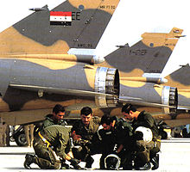](http://commons.wikimedia.org/wiki/File:Iraqi_pilots_of_mirage_F1_before_mission_in_Iran.jpg)[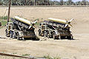](http://commons.wikimedia.org/wiki/File:Two_FROG-7.JPEG)[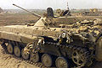](http://commons.wikimedia.org/wiki/File:Damaged_Iraqi_BMP-2.jpg)[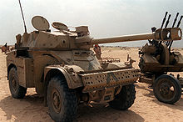](http://commons.wikimedia.org/wiki/File:AML-90_DM-SC-91-12079.JPEG)[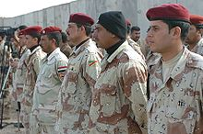](http://commons.wikimedia.org/wiki/File:Test_class_Graduates_Iraqi_NCO_Academy.jpg)[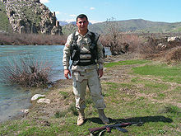](http://commons.wikimedia.org/wiki/File:KurdishPeshmerga.JPEG)[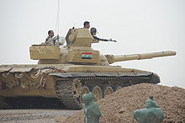](http://commons.wikimedia.org/wiki/File:T-72Iraq2008.JPG)[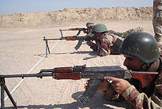](http://commons.wikimedia.org/wiki/File:Iraq_RPK_Machine_Gun.jpg)[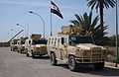](http://commons.wikimedia.org/wiki/File:Dzik-3.jpg)[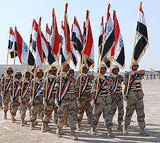](http://commons.wikimedia.org/wiki/File:080216_3-14_graduation.jpg)[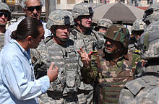](http://commons.wikimedia.org/wiki/File:GEN_Petraeus_Walking_Through_Market_11_March_2007_in_Baghdad.jpg)